Community Survey Tool
PRE-construction survey for GI projects in new spaces
***Do you agree to participate in this research study?
No
Yes

Do you currently visit any parks in your community for exercise, socializing, or any other purpose?
- Yes
- No

How often do you visit those parks?
- About once a month
- A few times a year
- Never
- Daily
- A few times a week
- About once a week

- This project is designed to…(insert project benefits here – for example: make the park cooler, reduce flooding in and around the park, improve water quality, and provide a space for the community to gather).
What would you say is your level of awareness of the above benefits?
- Very aware
- Aware
- Neutral
- Not very aware
- Not aware

Please tell us how much you agree with the following statements:
 | Strongly Agree | Agree | Neutral | Disagree | Strongly Disagree
I have easy access to this park. | ○ | ○ | ○ | ○ | ○
This park increases my physical fitness. | ○ | ○ | ○ | ○ | ○
Visiting this park decreases my stress. | ○ | ○ | ○ | ○ | ○
This park is safe. | ○ | ○ | ○ | ○ | ○
This park benefits the natural environment. | ○ | ○ | ○ | ○ | ○
- How old are you?
- 56-75
- 76 and older
- Do not wish to share
- Under 18
- 18-35
- 36-55

- Which of the following best describes your gender identification? (Please select one)
- Other:____________
- Do not wish to share
- Male
- Female
- Gender variant/nonconforming

- Do you consider yourself of Hispanic, Spanish, or Latino origin?
- Yes
- No
- Do not wish to share

- How do you describe yourself in terms of race (Please select one):
- White/Caucasian
- Other – Write in: ___________________
- Do not wish to share
- Asian
- Black/African American
- American Indian or Alaska Native
- Native Hawaiian or Pacific Islander
- Bi-racial or Multi-racial

Community Survey Tool
POST-construction survey for GI projects in new spaces
***Do you agree to participate in this research study?
No
Yes
No
Yes
- Do you live within a 10-minute walk from this park?

- 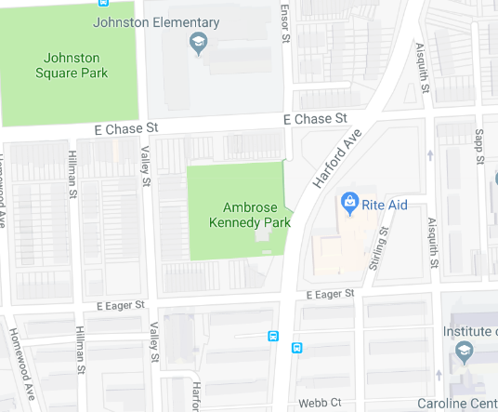About how often do you come to this park?
- About once a month
- A few times a year
- Never
- Daily
- A few times a week
- About once a week

- To the right is a map of the park showing where the Green Infrastructure project is located.
What would you say is your level of awareness of this project?
(Insert your map here)
- Very aware
- Aware
- Neutral
- Not very aware
- Not aware

- About how often did you come to community parks before this space opened?:
(Insert Date of Space Opening):

- Daily
- A few times a week
- About once a week

- About once a month
- A few times a year
- Never

About how often have you come to this new space since it opened? (Insert Date of Space Opening)
- About once a month
- A few times a year
- Never
- Daily
- A few times a week
- About once a week

Please tell us how much you agree with the following statements:
 | Strongly Agree | Agree | Neutral | Disagree | Strongly Disagree
I have easy access to this park. | ○ | ○ | ○ | ○ | ○
This park increases my physical fitness. | ○ | ○ | ○ | ○ | ○
Visiting this park decreases my stress. | ○ | ○ | ○ | ○ | ○
This park is safe. | ○ | ○ | ○ | ○ | ○
This park benefits the natural environment. | ○ | ○ | ○ | ○ | ○
- How old are you?
- 56-75
- 76 and older
- Do not wish to share
- Under 18
- 18-35
- 36-55

- Which of the following best describes your gender identification? (Please select one)
- Other:____________
- Do not wish to share
- Male
- Female
- Gender variant/nonconforming

- Do you consider yourself of Hispanic, Spanish, or Latino origin?
- Yes
- No
- Do not wish to share

- How do you describe yourself in terms of race (Please select one):
- White/Caucasian
- Other – Write in: ___________________
- Do not wish to share
- Asian
- Black/African American
- American Indian or Alaska Native
- Native Hawaiian or Pacific Islander
- Bi-racial or Multi-racial

